JAVA PROJECT

Use hardcoded values, Scanner input, arrays, collections and files.
01 Transaction validation: an amount above 0 is VALID; an amount of 0 or less is INVALID. Read transaction ID and amount with Scanner and print the result.

02 Create validate Transaction (double amount) and return VALID or INVALID. Call the method from your program.

03 Write 5000, -2500, 8000 and 0 to transaction.txt. Read them with Scanner and print the validation result for each value.

04 Create transactions.csv with a transaction_id,amount header and at least three records. Read each record and print the ID with VALID or INVALID.

Core Java Practice

TOPIC TWO QUESTIONS EACH
Array

1. Store five numbers in an array and print them.
2. Find the largest number in the array.

String

1. Print the length of a full name.
2. Check whether a string contains Java.

ArrayList

1. Add and print five student names.
2. Remove one name and print the updated list.

HashSet

1. Add and print five cities.
2. Add a duplicate city and print the set again.

HashMap

1. Store five student IDs with names.
2. Look up and print the name for a given ID.

01 Transaction validation: an amount above 0 is VALID; an amount of 0 or less is INVALID. Read transaction ID and amount with Scanner and print the result.

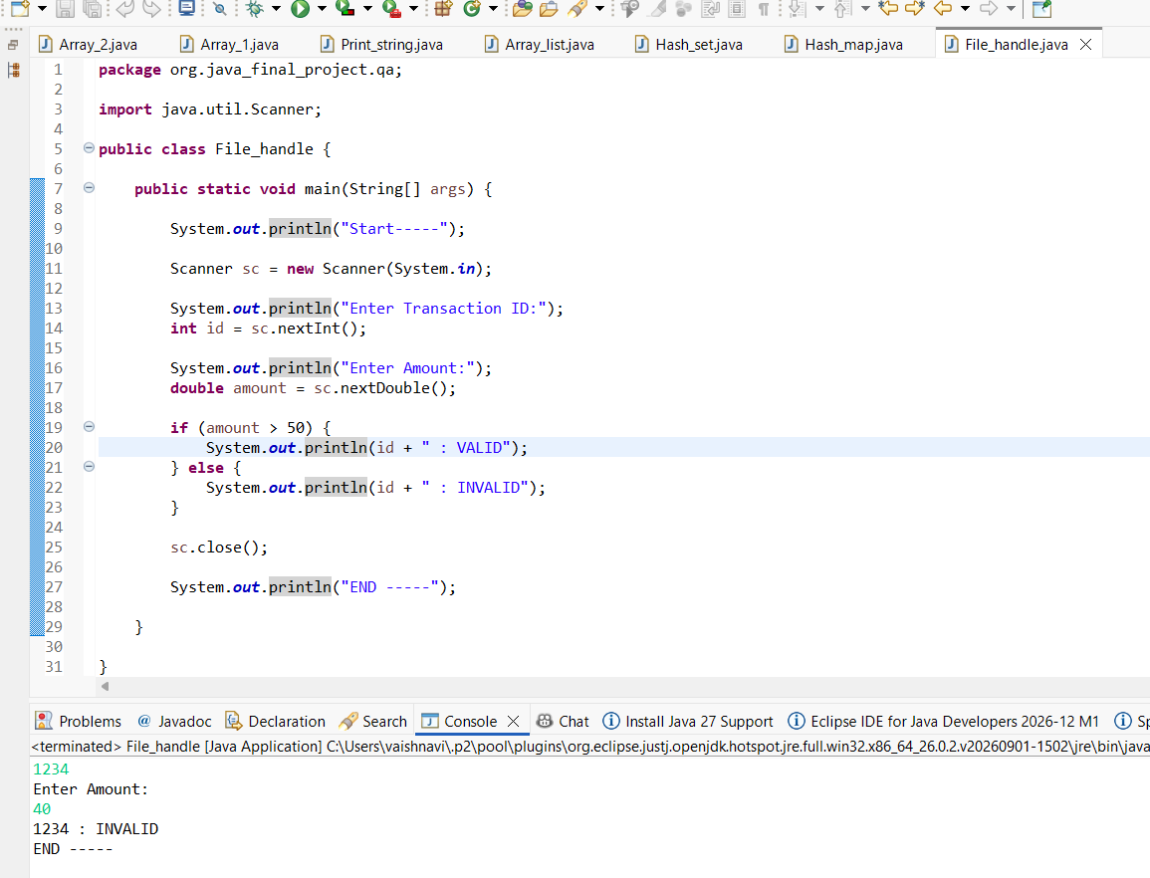

02 Create validate Transaction (double amount) and return VALID or INVALID. Call the method from your program.

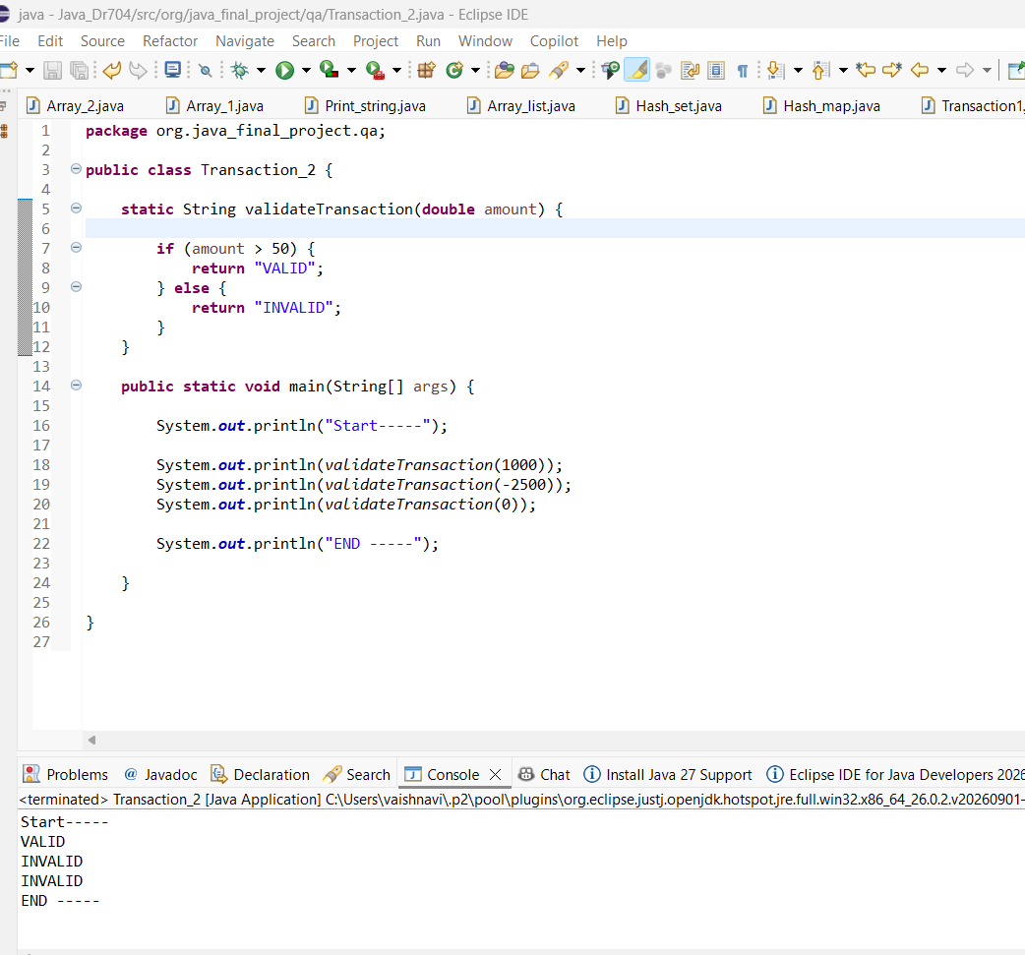

03 Write 5000, -2500, 8000 and 0 to transaction.txt. Read them with Scanner and print the validation result for each v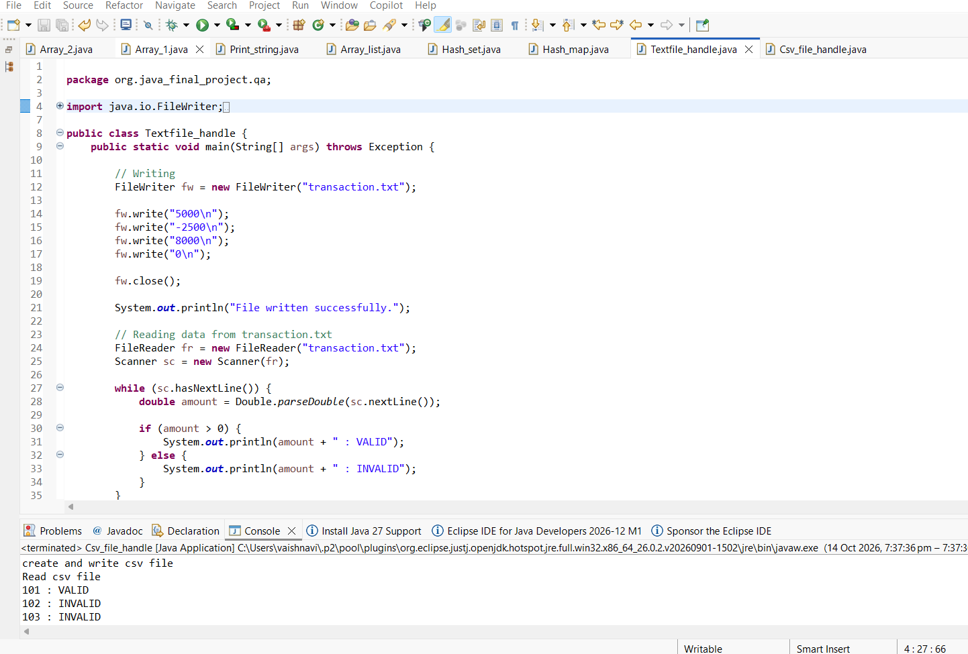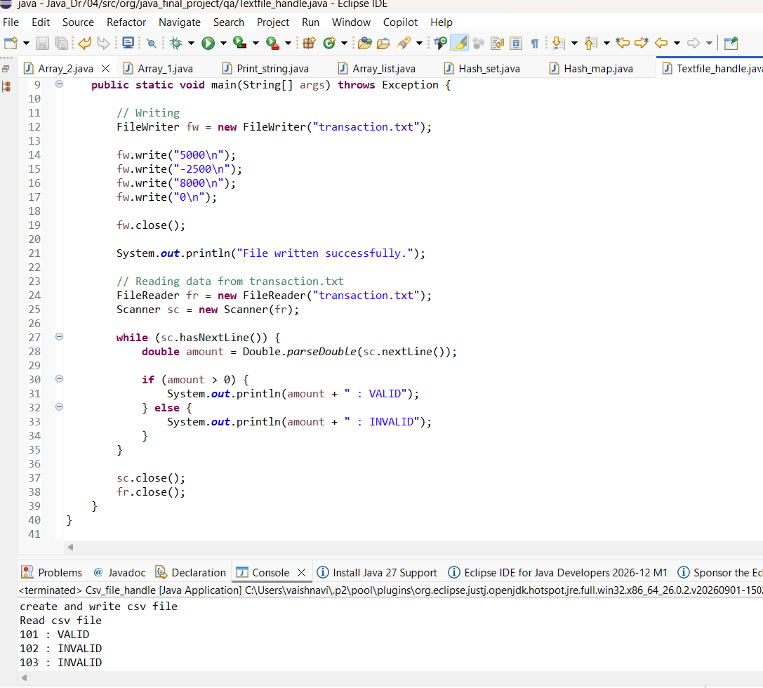

04 Create transactions.csv with a transaction_id,amount header and at least three records. Read each record and print the ID with VALID or INVALID.

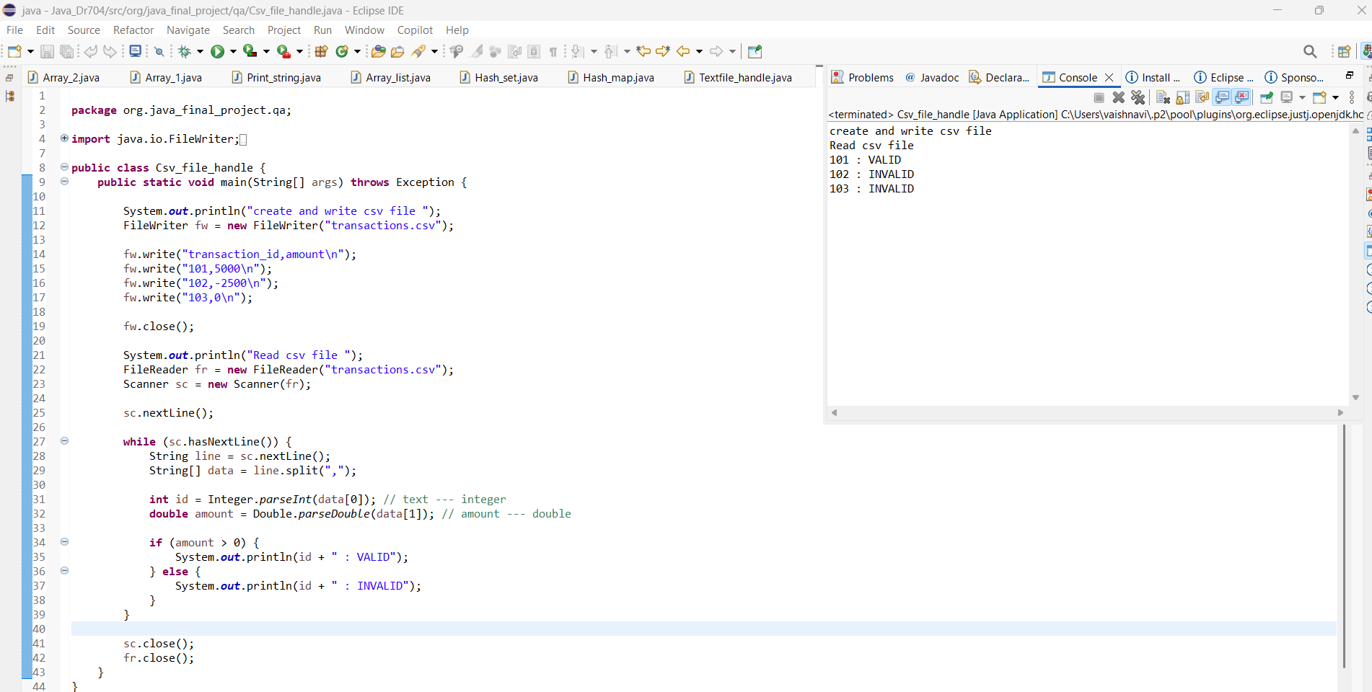

Array

1. Store five numbers in an array and print them.
2. Find the largest number in the array.

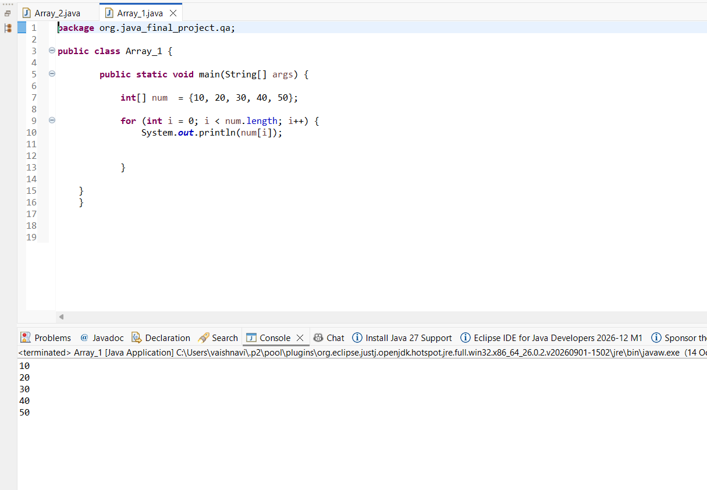

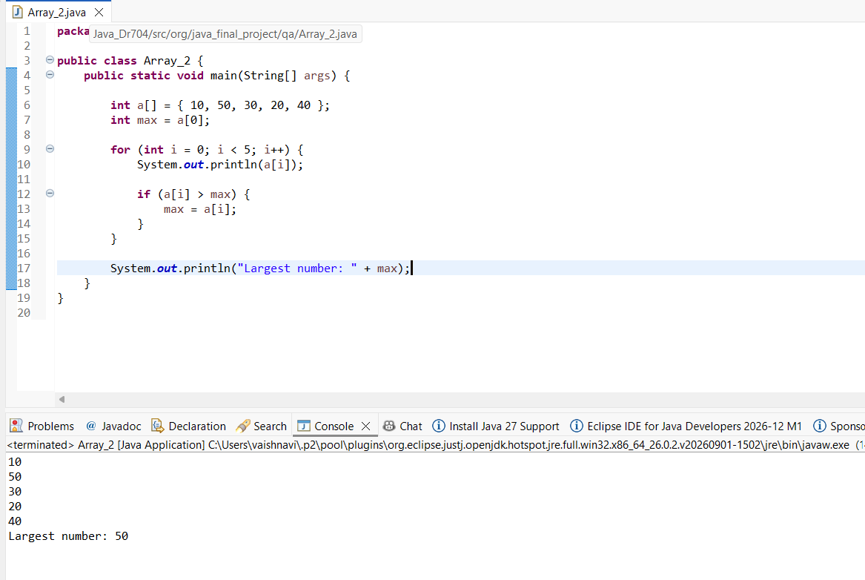
String

1. Print the length of a full name.
2. Check whether a string contains Java.

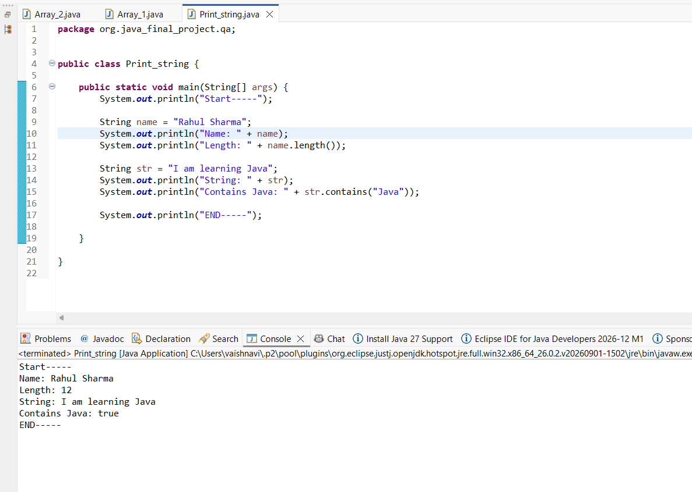

ArrayList

1. Add and print five student names.
2. Remove one name and print the updated list.

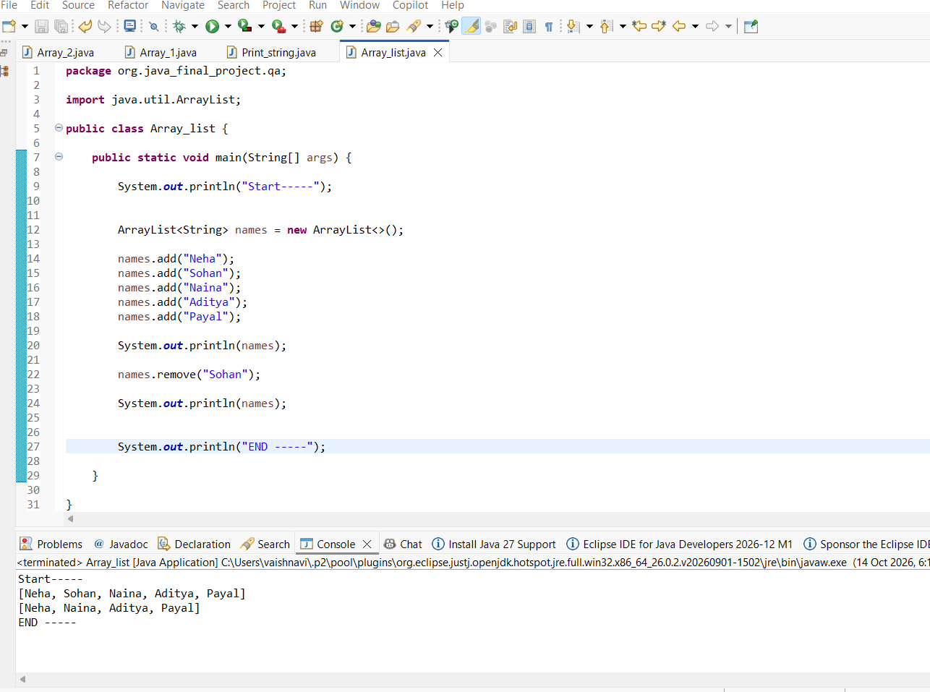

HashSet

1. Add and print five cities.
2. Add a duplicate city and print the set again.
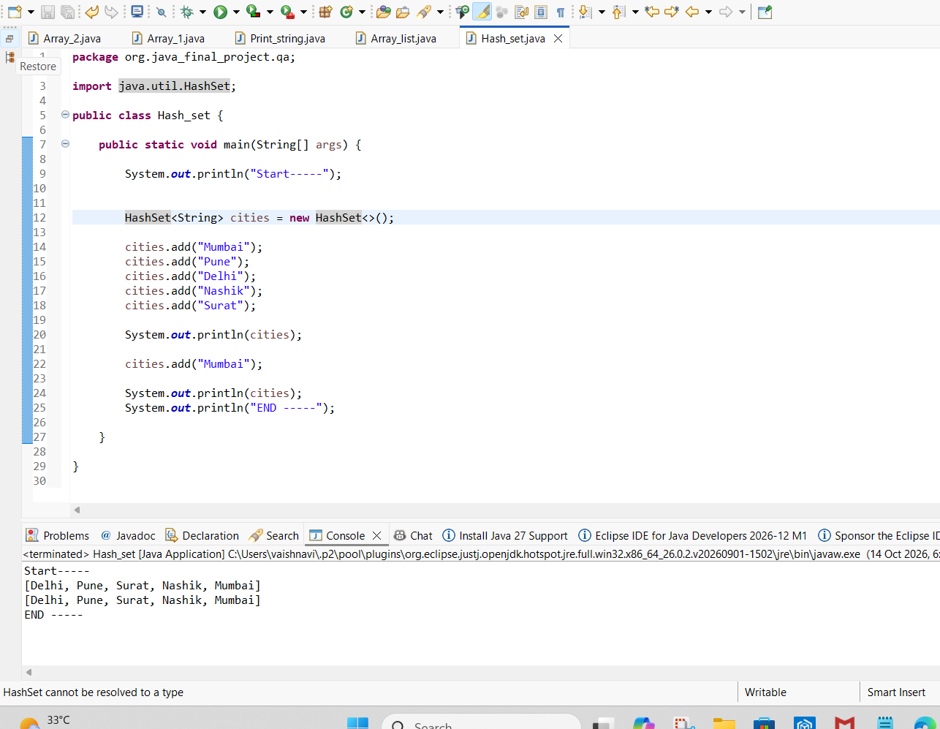

HashMap

1. Store five student IDs with names.
2. Look up and print the name for a given ID.
